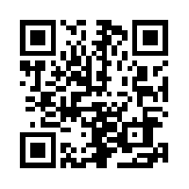 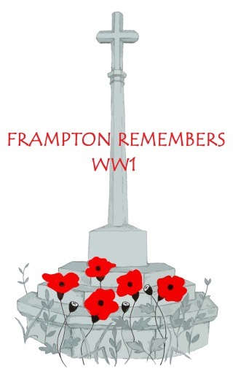 

***framptonremembersww1.org.uk***

**Frampton’s servicemen and nurses**﻿﻿﻿

Aldridge Francis William Hitchings Edgar

Berry Arthur David **Hitchings Frederick Robert William John**

Birch William George **Hitchings Percival Leonard**

Bradley Francis Hugh Hodder William Thomas

Bradley Percy John Hogg Albert Edward

Brazington Albert Joseph Hogg William Thomas

Brinkworth Harold William Hudson F (possibly Frank)

Brinkworth Thomas Hart Hunt Albert Edward

Camm Horace Edgar Hunt Arthur William

Camm Martin Walter William Hunt Thomas Edward

**Capener Edward Augustus**  Hunt Walter Edward

Causon William Henry Jones Frederick Alexander

Clifford Edith Katherine Jones John

Clifford Elaine Annie Jones Thomas Daniel

**Clifford Henry Francis**  Lanning John Henry

Clifford Mabel Constance Law William Reginald

Cole Thomas Henry Lawrence Arthur Edwin

Coleman Frederick Victor Lawrence Victor Charles

Cook Albert Ernest Leonard Cecil Charles

Cook Archibald Edward Light Edward Thomas Morse

Cook Frederick Gilbert Alexander Light Sidney John

Cook Raymond George Meadows Maurice

Cook William Frederick Millard John

Cook William John Mills Sidney Charles

Coole Frederick Mills Walter Harold

Coole Robert Edgar **Morgan William Henry**

Cottle Frederick William **Niblett William Thomas**

**Cottle Joseph Charles** Phipps Charles Henry

Cottle Joseph Thomas **Pitman Samuel**

Dark George Edward Pragnell George

Dark Stephen John **Prout Gerald**

Daw William James George **Purnell George Henry R (owles)**

Dennis Preston Rowles Francis Edwin John

Drayton Herbert Charles Rowles Richard William

Eaketts James Simmons Frederick George

Eaketts Willoughby Thomas Sims Frank Thomas

Estop Cecil Charles James Sims Thomas Ernest

Fletcher Gilbert John Sims Timothy John

**Fletcher Thomas Charles**  Sims William

**Folkes Alfred** Smith William

Franklin Francis Henry Sparry Charles William

Franklin Frederick Alexander **Staplehurst Alfred**

Fredericks Albert Thomas Stone William Henry

**Fryer Christopher Charles** Strahan Percy

Fryer Clevedon Wells Sutton Arthur Harry

Fryer Edgar John Tainton Ernest Walter Henry

Gabb Wilfred Harris **Tainton Walter Henry**

Gandy Peter **Townsend Albert Edward**

Gardner Frederick Charles Tudor Milton

Gleed Harold James Frederick Vick Cyril

Gleed William Joseph Ernest Watkins Wells Alexander

Godwin Jacob Jonas Weaver Frank

Goodman Ralph James Weller Charles Alexander

Gray Philip White Arthur Geoffrey

Griffin Thomas Henry Whithorn William

Guy Henry Elphinstone Wilks Ernest Henry

Gymer Walter Wilks Victor William

Halling Thomas George **Winter Richard Sidney**

Halling William

Harley J

Harris George

Hawker Thomas

Hawker Thomas Miles

Hazell Frederick William Phillips

Hazell Ralph Theodore

Herbert David George

Hill Frederick

Hill Henry John

Hitchings Ashley Victor

Hitchings Charles Henry

|  |
| --- |
|  |