 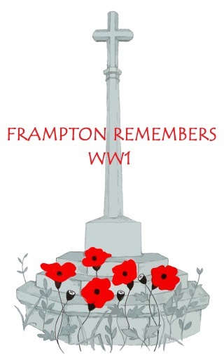 

***framptonremembersww1.org.uk***

**The Western Front battlefields**

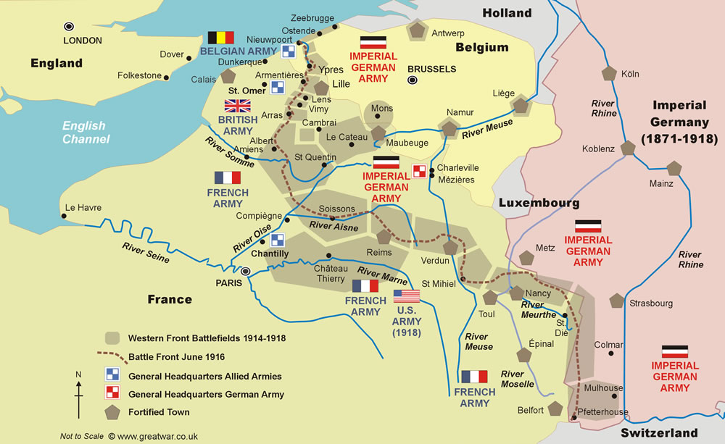

**Source: Reproduced by kind permission of www.greatwar.co.uk**

The First World War was fought globally, and Frampton's servicemen saw action on many fronts: the largest number were on the 'Western Front' shown here, but others were fighting in the Balkans, Gallipoli (Turkey), Mesopotamia (now Iraq), Egypt and Palestine. At sea, our sailors would have been found in the North Sea, the Channel, the Atlantic and the Mediterranean – and our merchant seamen both around our coasts and anywhere throughout the world.

Other theatres of war included the Eastern Front (where Germany and Austro-Hungary confronted Russia), the Caucasus, the Alps, and actions against German colonies in the Pacific, West Africa (Togoland and Kamerun), South-West Africa and East Africa (Tanganyika) – where fighting continued until the Armistice.